Dear hostelguest,
We’re currently working hard on the hostel’s future. We believe that a good bed is one of the (if not the) most important thing a quality hostel should offer.

Our hostel, together with students of the University of Applied Sciences Salzburg has started the development of a complete new style of hostelbeds. To get some ideas we ask you for your creativity by drawing your perfect hostel(bunk)bed.

Many thanks!

Date:
E-mail:

The perfect bunk bed by:

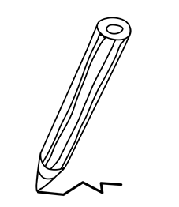

As a THANK YOU for your creative idea you'll get our traditional
“Opfistrudl-shot” (apple strudel-shot) & a (optional) free hug!
The data is used for university research only and won’t be handed out to third parties.

